Data Communication and Network
LAB

FAROOQ AHMAD Experiment # 8
17L4407 Lab Report # 7
BEE-5A

Wire SHARK NETWORK ANALYSIS

INTRODUCTION
In this lab session, we were introduced to the wire shark network analysis.
Wireshark is a GUI network protocol analyzer. Wireshark (Ethereal) is a packet sniffing too, a packet sniffer captures messages being sent/received from/by your computer, it will also typically store and/or display the contents of the various protocol fields in these captured messages. A packet sniffer observes messages being sent and received by applications and protocols running on your computer, but never sends packets itself. Similarly, received packets are never explicitly addressed to the packet sniffer. Instead, a packet sniffer receives a copy of packets that are sent/received from/by application and protocols executing on your machine. Wireshark's native capture file format is pcapng format, or pcap which is also the format used by tcpdump and various other tools.

OBJECTIVE

The course learning objective of this lab session was to introduce us to the wire shark network analysis of a computer network device and to learn the use of Wireshark to understand different Internet Protocol.

DESIGN PROCEDURE
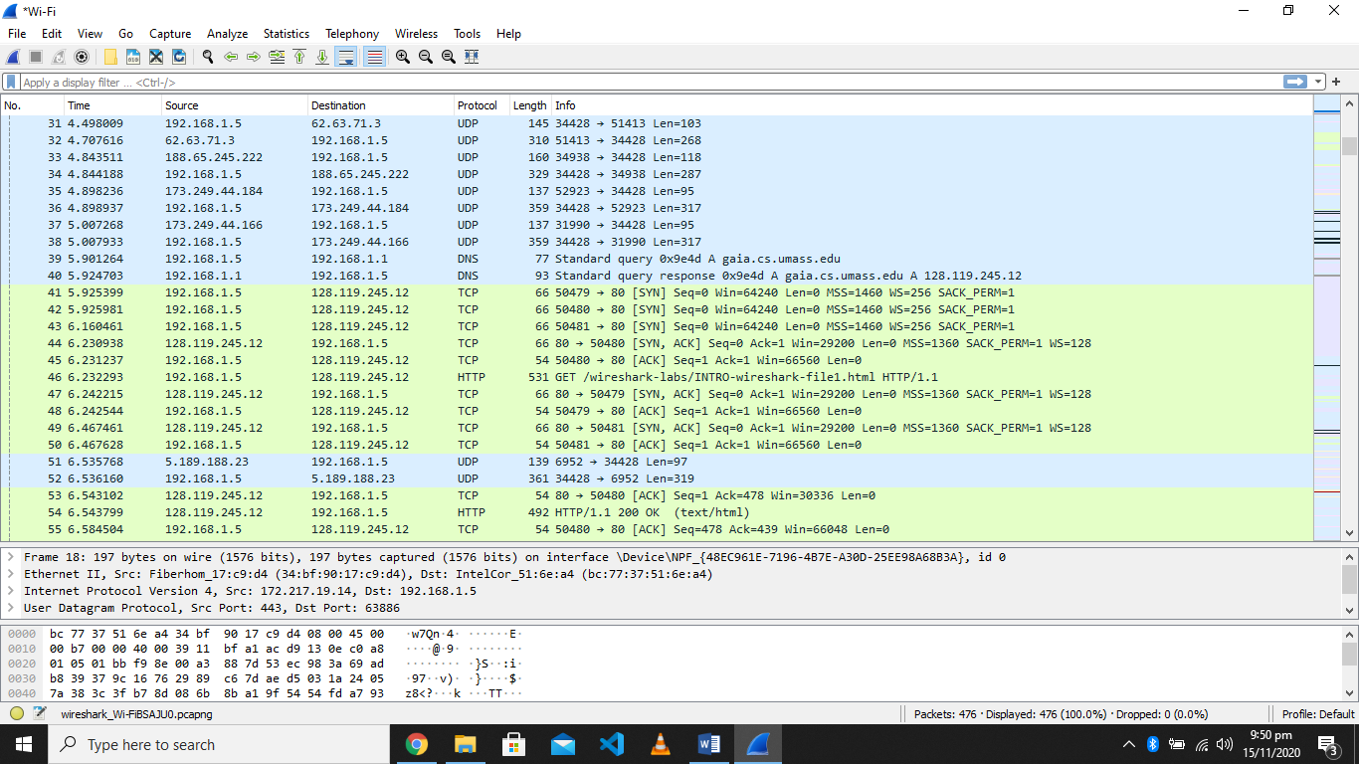
• List up to 10 protocols that appear in the protocol column
- UDP
- SSDP
- QUIC
- DNS
- TCP
- TLS
- ICMP
- HTTP
- ARP
- IGMP

• How long did it take from when the HTTP GET message was sent until the HTTP OK reply was received?
6.543799-6.232293 = 0.311506
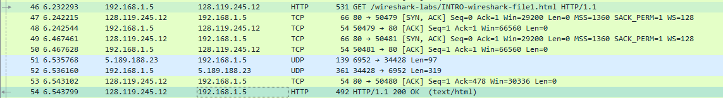

• What is the Internet address of the gaia.cs.umass.edu? What is the Internet address of your computer?
My computer -> source
gaia.cs.umass.edu -> destination

• Write down the sequence number of the first TCP packet
21
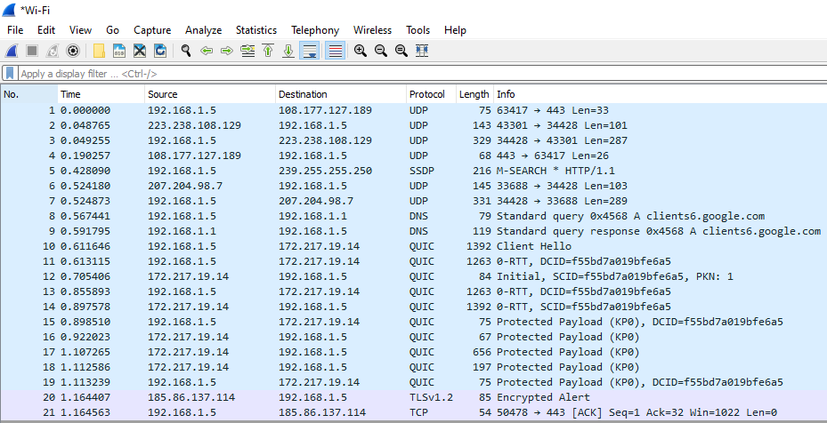

ISSUES
There were as such none issues.

CONCLUSION
This lab session was conducted successfully. The most used tool for network analysis was introduced and learn to use. It was learnt how to use the wire shark network analyzer to understand different internet protocol. Wireshark is a network protocol analysis tool. At its core, Wireshark was designed to break down packets of data being transferred across different networks. The user can search and filter for specific packets of data and analyze how they are transferred across their network.

APPLICATIONS
Wireshark is the world’s foremost and widely-used network protocol analyzer. It lets you interactively browse packet data from a live network or from a previously saved capture file. It lets you see what’s happening on your network at a microscopic level and is the de facto (and often de jure) standard across many commercial and non-profit enterprises, government agencies, and educational institutions.

POST LAB
Question 1.
TCP three-way handshaking is a method by which two devices can begin to start communicating. Before any data is transferred, a device sends a SYN(Synchronization) packet to another device to notify it about the possible communication. The second device then sends a SYN-ACK (Synchronization Acknowledged) packet to notify that it is ready to communicate. After this the first device sends and ACK(Acknowledgement) packet to the second device, and then a connection is established and data is transferred.
Question 2.
The ACK flag notifies the correct arrival of a packet, whereas the FIN flag tells us about the end of communication.

